CS 340 README

About the Project/Project Title:
This project is to visualize and filter the data given in a given CSV file, being outcomes at the Austin Animal Center.

Motivation:
This project is to be able to pull desired data from the data set, visualize it either through tables, graphs, or maps and be able to filter the data to find specific data points. Being able to do this is vital to aggregate data forms so that it is easier to digest and be able to find specific data elements easier.

Getting Started:
We need the code base for simple management of documents loaded into a MongoDB. This project is using a previous implementation in CRUD_Python_Module.py

We need to next load the database into the MongoDB, through the aac_shelter_outcomes.csv using the shell commands.

This module uses libraries imported from JupyterDash, plotly, and dependencies from dash. Additionally, we use base64 for encoding, import os for OS routines and math libraries in numpy, pandas, and matplotlib.pyplot.

Usage
This module is used to visualize and sort the data of the given database.

We accomplish this by pushing the database into a table as a visualization and filtering functions using callbacks to update the dashboard (update_dashboard).

The next callback function is to update the graph, a pie chart (update_graphs).

We also have the update map callback (update_map) as an additional visualization of geographical location tied to the data.

Lastly, we have a callback to update the style (update_style) to highlight a selected column.

Each of the functions are all used to sort, filter, and or visualize the data to better understand the data given. Each had small hurdles to overcome but each follow Object-Oriented Programming principles like through encapsulation.

Code Example
Import the database and setup permissions:
Using a CSV file imported into MongoDB, we can create a user with privileges to affect changes in the database

cd ./datasets
mongoimport --type=csv --headerline --db aac --collection animals --drop ./aac_shelter_outcomes.csv
mongosh
use admin
db.createUser( { user: "aacuser", pwd: passwordPrompt(), roles: [ { role: "readWrite", db: "aac" } ] } )

Ensure database authentication is completed and functional:

USER = 'aacuser'
PASS = 'pass'
HOST = 'localhost'
PORT = 27017
DB = 'aac'
COL = 'animals'
#
# Initialize Connection
#
self.client = MongoClient('mongodb://%s:%s@%s:%d' % (USER,PASS,HOST,PORT))
self.database = self.client['%s' % (DB)]
self.collection = self.database['%s' % (COL)]

The database set up is “aac” with collection of “animals”. A user with read/write privileges has been created and may call these functions.

# Create instance of the Animal Shelter Class

# insert document
instance.insert_document("database", "collection", document)

# query document
result = instance.document_query("database ", " collection ", {"key": "value"})

We have set up the use of radial buttons to filter the data and have variables to be used in the respective update function for later on through the ‘id’=‘filter-type’.

# setup of radial button filters
dcc.RadioItems(
id='filter-type',
options=[
{'label': 'Water Rescue', 'value': 'Water Rescue'},
{'label': 'Mountain Rescue', 'value': 'Mountain Rescue'},
{'label': 'Disaster Rescue', 'value': 'Disaster Rescue'},
{'label': 'Tracking', 'value': 'Tracking'},
{'label': 'All', 'value': 'All'}
],
value='All', # Default on All
inline=True,
style={'padding': '10px'}
)
]),
html.Hr(),

We set up the table to be created and be used for visualization of the data and is able to be affected by the filters (above)

# Creating the data table

dash_table.DataTable(id='datatable-id',
columns=[{"name": i, "id": i, "deletable": False, "selectable": True} for i in df.columns],
data=df.to_dict('records'),

To update the dashboard when the filters are selected, we need the types on the filters mapped to what identifiers are in the data. In this case it is the rescue types matched to their respective breeds. Once we have this map, we have to build the query for the database and pass the results to the basic query_document function to query the database. The results are then formatted and returned to data table to complete the function.

@app.callback(Output('datatable-id','data'), [Input('filter-type', 'value')])
def update_dashboard(filter_type):

# If "All" → return full dataset
# Rescue Type Preferred Breeds mapping
rescue_map = {
"Water Rescue": ["Labrador Retriever", "Newfoundland", "Portuguese Water Dog"],
"Mountain Rescue": ["German Shepherd", "Belgian Malinois"],
"Disaster Rescue": ["Doberman Pinscher", "Rottweiler"],
"Tracking": ["Bloodhound", "Coonhound"]
}

# Build query
if filter_type is None or filter_type == "All":
query = {}
else:
query = {"breed": {"$in": rescue_map[filter_type]}}

# Query MongoDB using your CRUD module
results = shelter.query_document("aac", "animals", query)

# Convert results to DataFrame
df = pd.DataFrame(list(results))

# Drop MongoDB internal ID field
if "_id" in df.columns:
df.drop(columns=['_id'], inplace=True)

# Return only the data for the DataTable
return df.to_dict('records')

Much in the same way the dashboard gets updated, the graph update is pushed when the table is changed so that it can be built on the data points. In this case, the data point is the breed type and is a pie chart.

@app.callback(
Output('graph-id', "children"),
[Input('datatable-id', "derived_virtual_data")])

def update_graphs(viewData):
if viewData is None:
dff = pd.DataFrame()
else:
dff = pd.DataFrame(viewData)

# If the table is empty, return an empty graph
if dff.empty or "breed" not in dff.columns:
return [
dcc.Graph(
figure=px.pie(
names=[],
title="No Data Available"
)
)
]

# Create a pie chart of breed counts
fig = px.pie(
dff,
names ='breed',
title ='Preferred Animals'
)

return [
dcc.Graph(figure=fig)
]

Tests
Describe and show how to run the tests with code examples.

Screenshots
Provide screenshots that demonstrate your work.

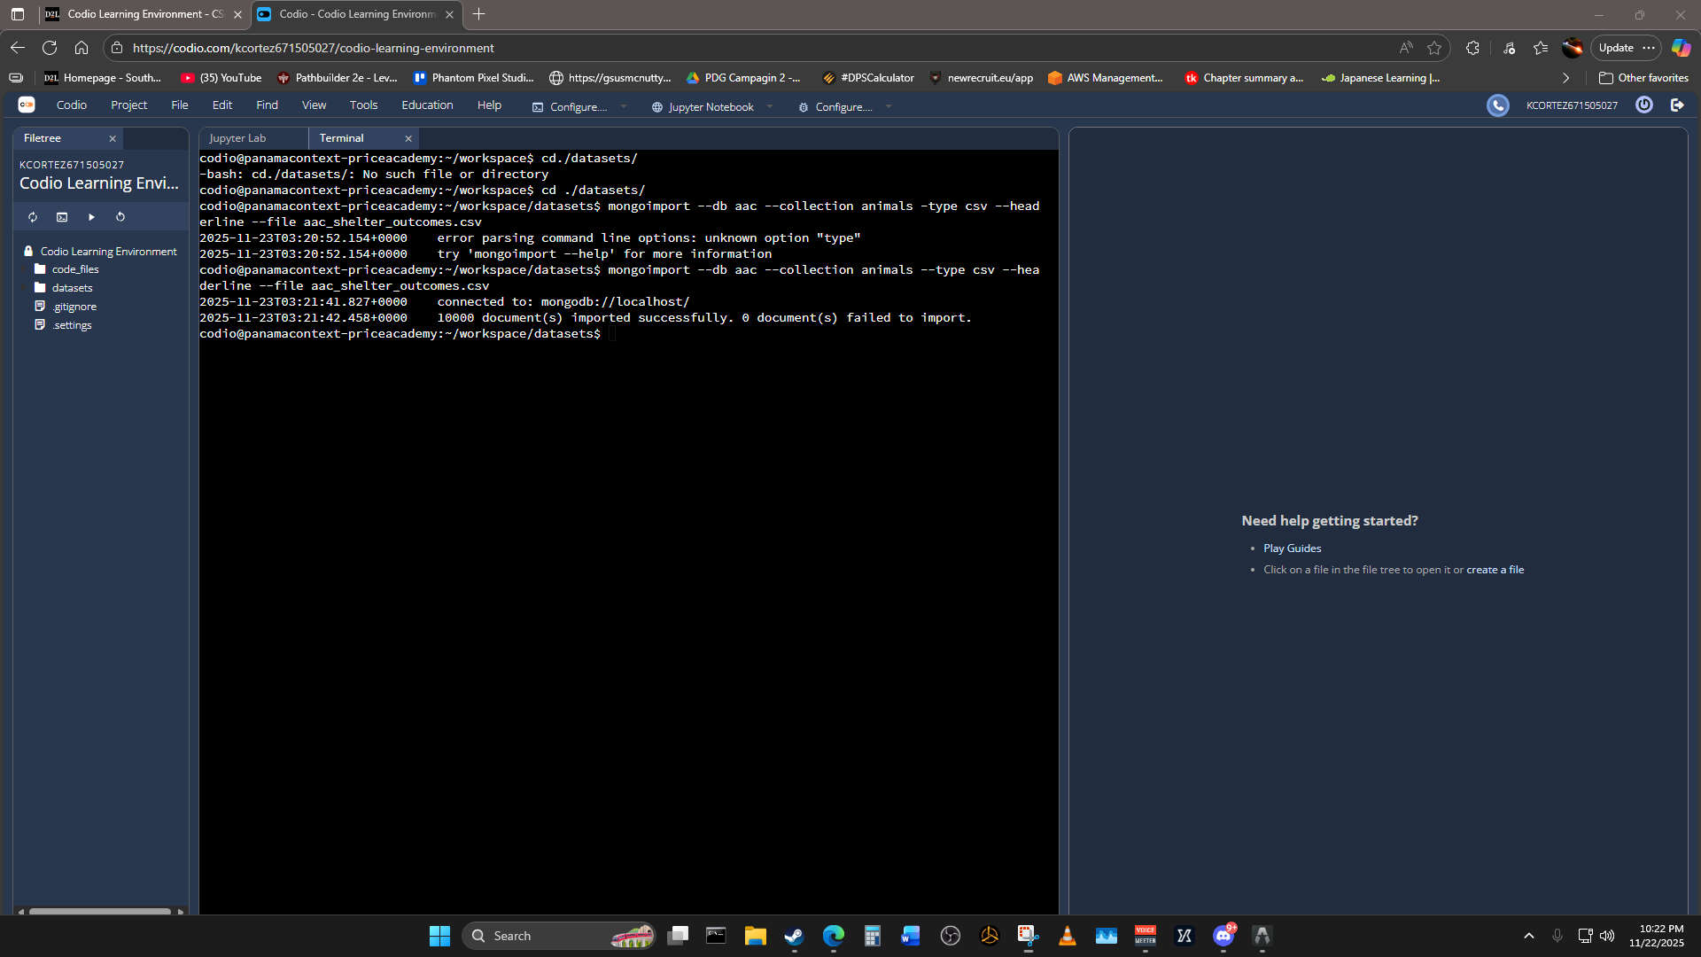

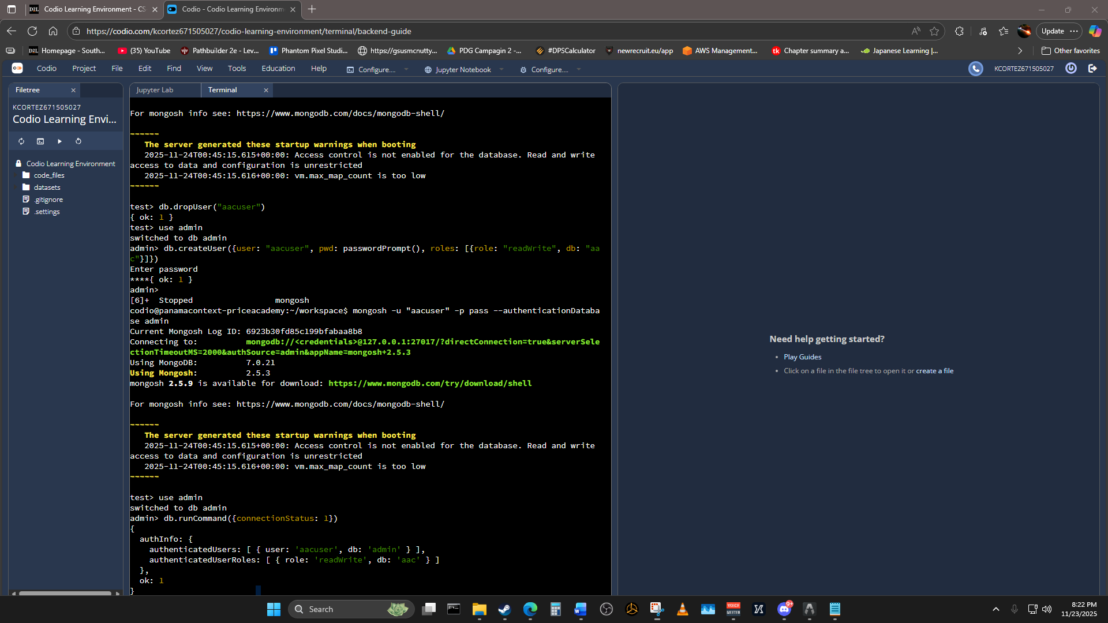

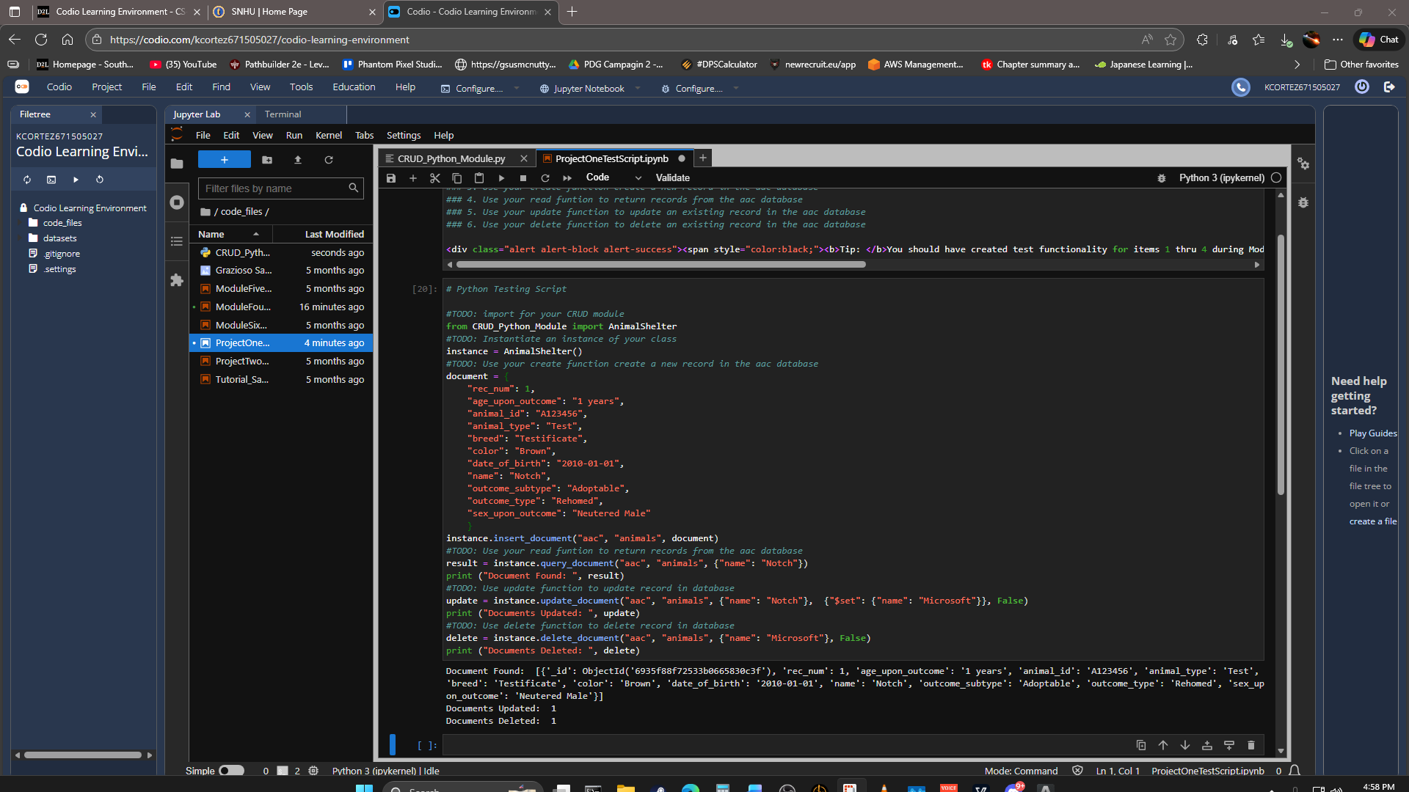

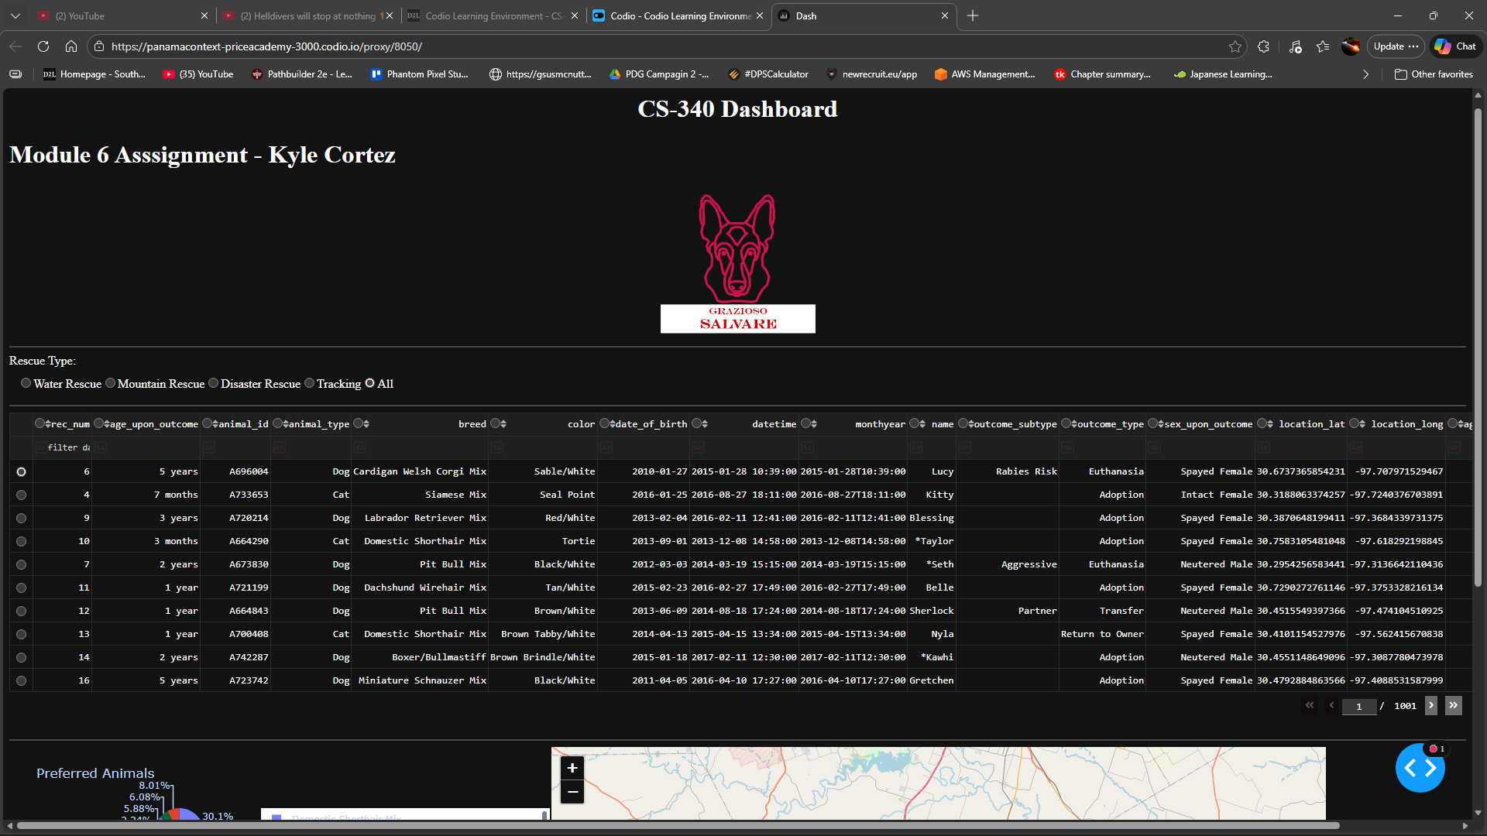

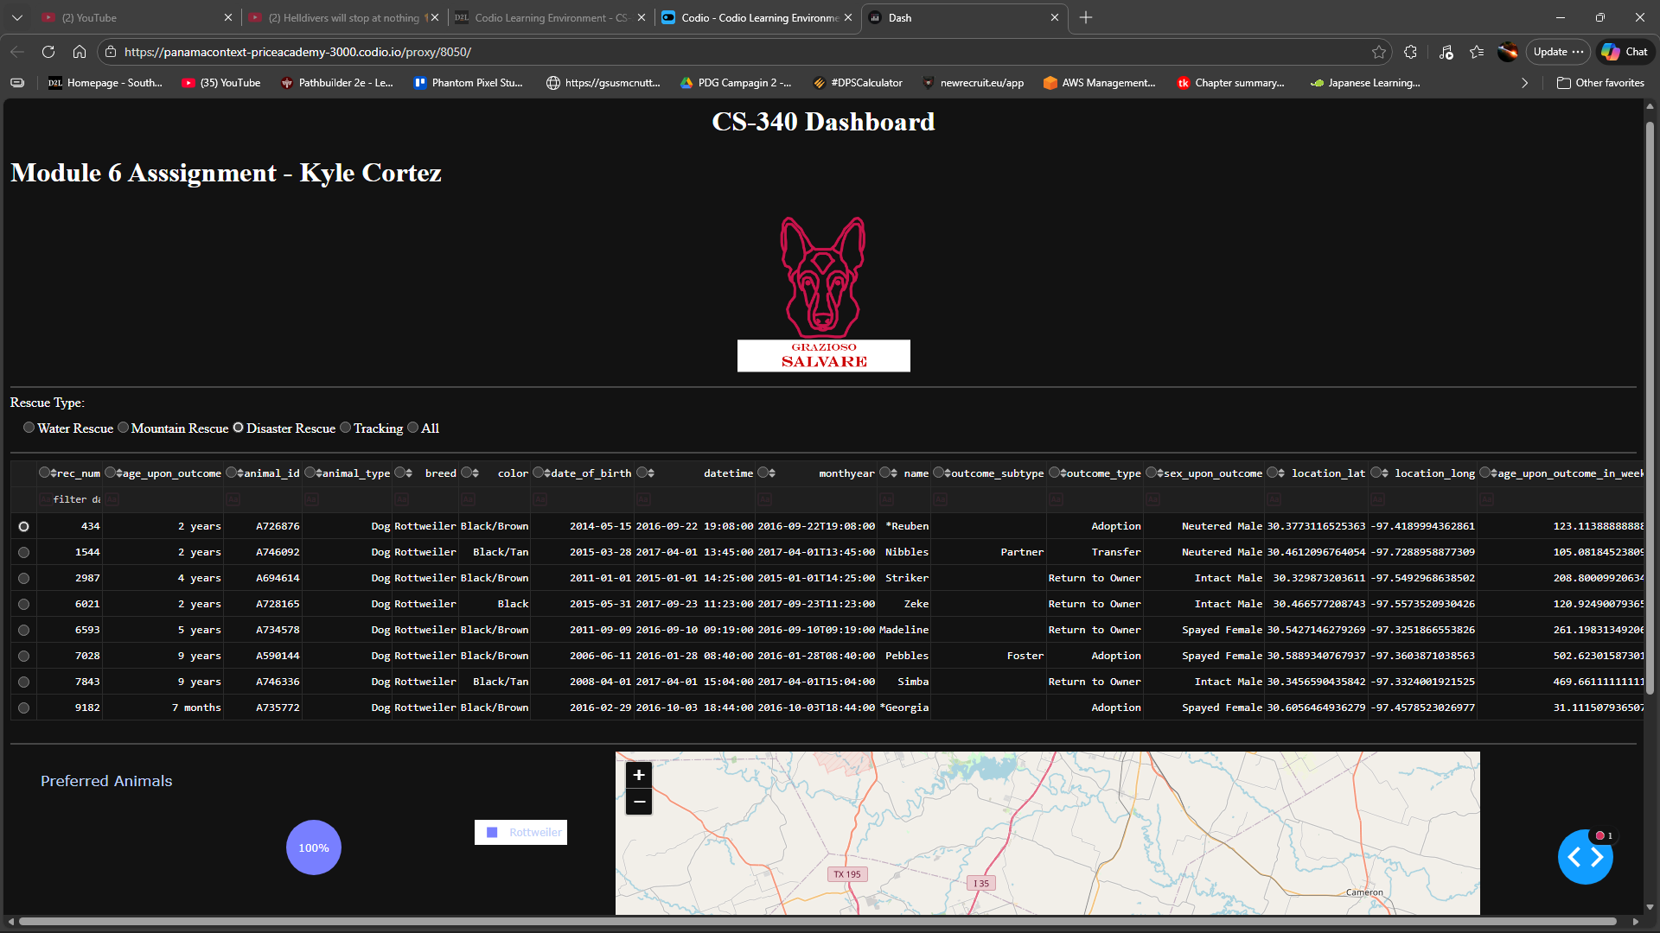

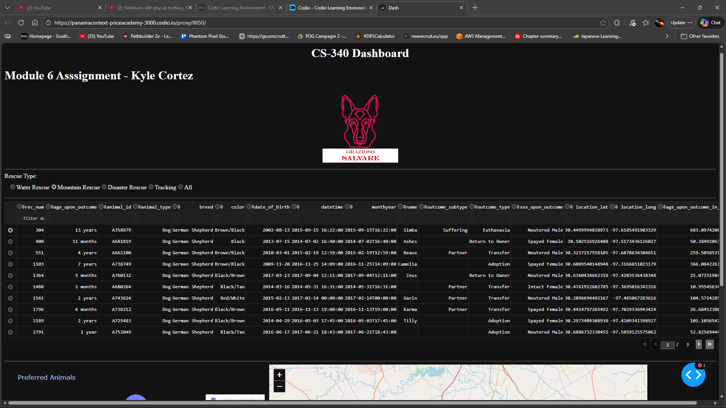

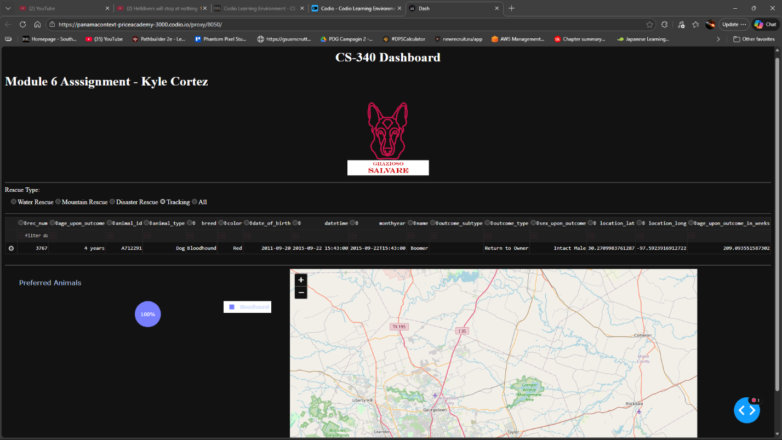

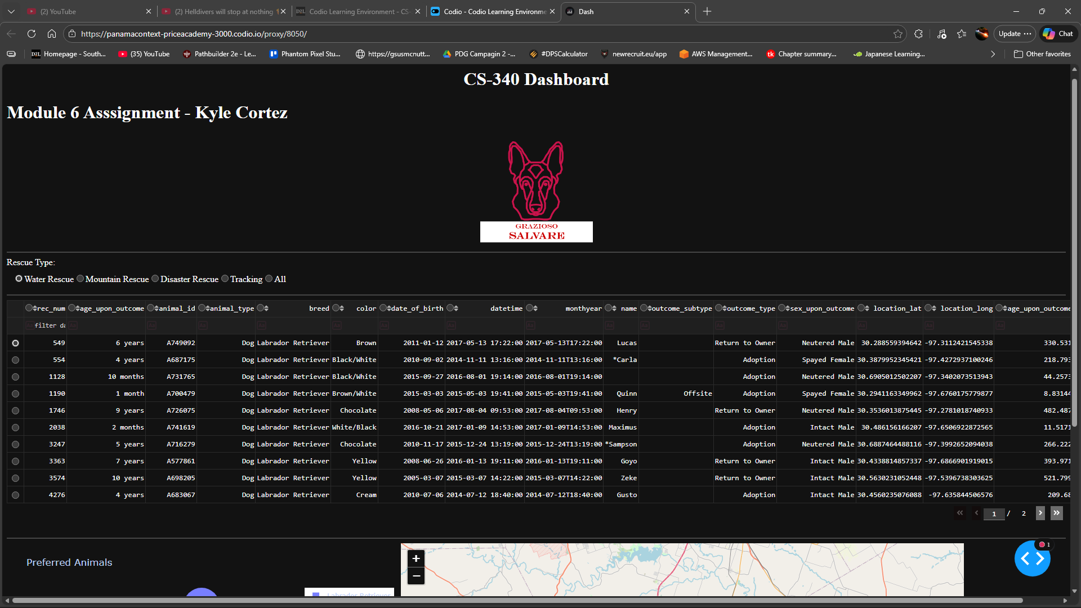

Contact
Your name: Kyle Cortez

